IoT (Internet of things)

**What is IoT ?**

One of the most dynamic and exciting developments in information and communication technology is the advent of internet of things (IoT). The internet of things or IoT, is a system of interrelated computing devices, mechanical and digital machines, objects, animals or people that are provided with unique identifiers and the ability to transfer data over a network without requiring human-to-human or human-to-computer interaction.

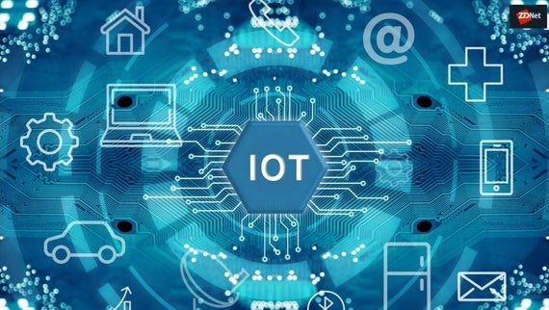

**How does it work ?**

An IoT ecosystem consists of web-enabled smart devices that use embedded systems, such as processors, sensors and communication hardware, to collect, send and act on data they acquire from their environments. [IoT devices](https://internetofthingsagenda.techtarget.com/definition/IoT-device) share the sensor data they collect by connecting to an [IoT gateway](https://whatis.techtarget.com/definition/IoT-gateway) or other edge device where data is either sent to the cloud to be analysed or analysed locally. Sometimes, these devices communicate with other related devices and act on the information they get from one another. The devices do most of the work without human intervention, although people can interact with the devices -- for instance, to set them up, give them instructions or access the data.

**What is an example of an Internet of Things device?**

Pretty much any physical object can be transformed into an IoT device if it can be connected to the internet to be controlled or communicate information.

[A lightbulb](https://www.zdnet.com/article/building-my-own-internet-of-things-ambient-experience-one-step-at-a-time/) that can be switched on using a smartphone app is an IoT device, as is a motion sensor or a [smart thermostat](https://www.zdnet.com/article/johnson-controls-cortana-powered-thermostat-is-up-for-preorder-in-march/) in your office or a connected streetlight. An IoT device could be as fluffy as [a child's toy](https://www.zdnet.com/article/fbi-to-parents-beware-your-kids-smart-toy-could-be-a-security-risk/) or as serious as [a driverless truck](https://www.zdnet.com/article/driverless-trucks-are-coming-but-for-now-adoption-is-in-the-slow-lane/). Some larger objects may themselves be filled with many smaller IoT components, such as a jet engine that's now filled with thousands of sensors collecting and transmitting data back to make sure it is operating efficiently. At an even bigger scale, [smart cities projects are filling entire regions with sensors](https://www.zdnet.com/article/las-vegas-announces-smart-city-plans-with-cisco/) to help us understand and control the environment.

**What are the benefits of the Internet of Things for business?**

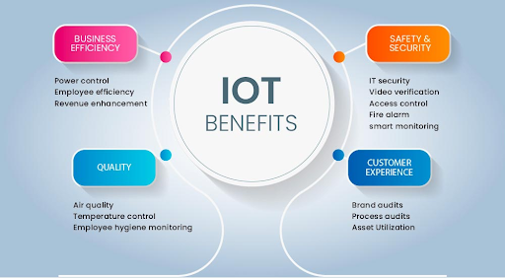

**1. Cost reduction**

The more businesses use IoT devices to streamline operations and increase profitability, the more Internet of Things technologies will be tailored to help those businesses succeed. From [cybersecurity](https://impactmybiz.com/company/article/274/cybersecurity-digital-transformation-are-they-a-match-) to workplace efficiency, IoT devices are already making an impact on companies’ bottom lines. Maintenance costs can be positively impacted when IoT devices are used with sensors to keep business equipment running at peak efficiency. On-the-fly troubleshooting of office equipment catches problems before they impact staff and employees, saving the hassle and costs of large repairs.

### 2. Efficiency & productivity

Efficiency is the basis for the kind of improved productivity that boosts revenue for SMBs. One way to leverage the power of IoT to increase company efficiency is to use it to cut down on repetitive or time-consuming tasks. An example IoT function for this strategy would be an [automated PDF conversion and creation tool](https://www.information-age.com/enterprise-iot-workplace-efficiency-123483826/) that removes the obstacles to PDF editing and archiving, increasing communication and documentation speeds.

### 3. Business opportunities

While many businesses strive to access the revenue-producing power of digital services, most lack a cohesive strategy for pursuing this avenue. IoT is a game-changer in this respect, as advanced analytics, artificial intelligence, and smart utility grids make it easy for SMBs to collect actionable data needed to provide the value their customers are seeking. For example, IoT sensors on automobiles that can track speed and driving habits help insurers optimize rates on automobile insurance. [Retailers can use IoT](https://www.impactmybiz.com/blog/internet-of-things-in-retail/) to measure in-store foot traffic to optimize displays for maximum impact based on customer habits.

### 4. Customer experience

While IoT technology has so far mostly influenced back-end processes because of its relatively new presence, today’s IoT has meant that omni-channel strategies have completely upended the way consumers approach their relationships with businesses.

Front-end [customer engagement](https://impactmybiz.com/company/article/290/why-it-s-important-to-provide-an-optimized-digital-customer-experience) has become a priority for organizations as they look to engage better with their audiences, usually through IoT devices.

### 5. Mobility & agility

The nature of IoT technology means that businesses now have the opportunity to let their employees conduct their work from virtually any location—flexibility that can provide key advantages to SMBs in particular. Office leases aren’t cheap, and the IoT revolution has allowed a surge in small and mid-sized businesses changing the way they operate—hiring more full-time remote employees in “work from anywhere” positions.